Breaking Deterministic Thinking
In previous clustering methods, algorithms look at distance and draw strict boundaries. This is called deterministic thinking. In reality, data is rarely separate and clear. To build better models, we must understand why basic algorithms fail.

Limitations of K-Means Clustering
K-Means is fast, but it forces data to follow strict rules. If the data does not follow these rules, the algorithm produces incorrect groups.
Assumptions of K-Means
- Spherical Clusters: K-Means groups points based on their straight-line distance (Euclidean distance) from a center point (centroid). Because it measures distance equally in all directions, it assumes every cluster is a perfect circle or sphere. It cannot process stretched or elliptical groups well.
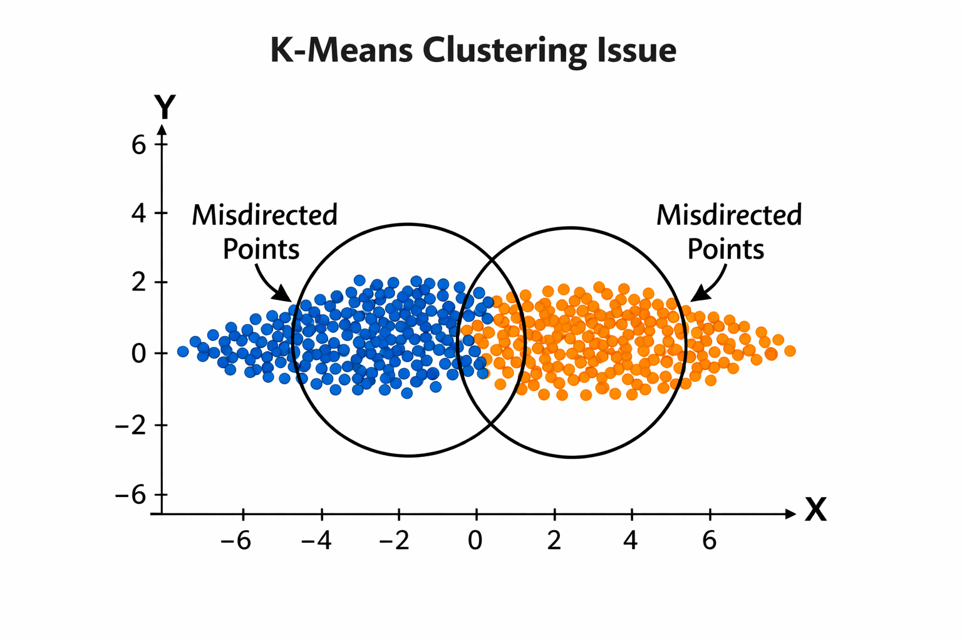
- Equal Variance: K-Means assumes all clusters have the same volume and density. If one cluster is spread out and an adjacent cluster is tightly packed, K-Means will draw a boundary directly through the larger cluster.
Failure Cases
- Overlap: When data points from two categories overlap, K-Means draws a hard line through the overlapping region. It does not account for the uncertainty of the points in that shared space.
- Noise: K-Means assigns every single point to a cluster. It does not identify outliers. A stray data point will pull the centroid away from the actual group.
- Non-Convex Shapes: A convex shape is solid, like a circle. A non-convex shape is irregular, like a ring or a crescent. Because K-Means only looks for center points, it will slice a ring shape into pieces instead of identifying the ring as a single continuous cluster.
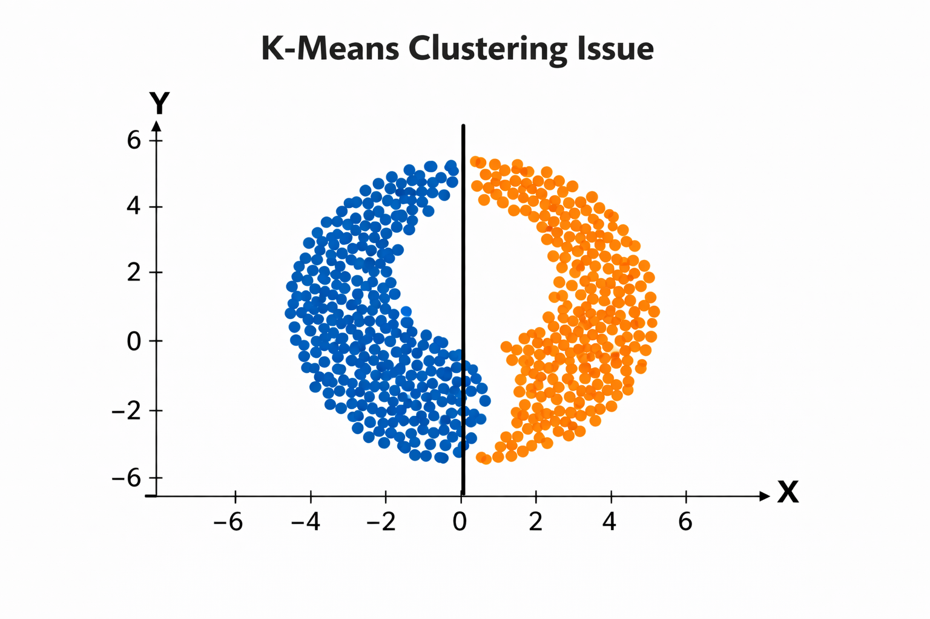

Hard vs. Soft Clustering
Algorithms like K-Means and DBSCAN use hard clustering. To handle overlapping data, we must switch to soft clustering.
Hard Clustering (Binary Assignment)
- In hard clustering, a data point belongs to exactly one cluster.
- Mathematical notation: We assign a label z_{i} to a data point x_{i} . If there are K clusters, z_{i} is exactly one integer from the set {1, 2, ..., K} . There are no fractions.
- If a point sits directly on the border between Cluster 1 and Cluster 2, the algorithm forces it into one of them. This binary assignment ignores the mathematical uncertainty.
Soft Clustering (Probabilistic Assignment)
- Soft clustering assigns a probability distribution to each data point.
- These probabilities are later computed using Bayes’ rule by combining how likely the data point is under each cluster and how common each cluster is.
- These probabilities are computed using probability density functions, where each cluster is modeled as a distribution (typically Gaussian), and assignments are based on how likely a point is under each distribution
- Mathematical notation: Instead of a single integer, we calculate a probability P(z_{i} = k | x_{i}) .
  - x_{i} : The specific data point we are looking at.
  - k : A specific cluster.
  - z_{i} = k : The event that point i belongs to cluster k .
  - P(z_{i} = k | x_{i}) : The probability that point i belongs to cluster k , given its location.
- A point is not just "Cluster 1." Its assignment is a list of probabilities: 70% Cluster 1, 25% Cluster 2, and 5% Cluster 3. The sum of these probabilities always equals 1.0 (or 100% ).
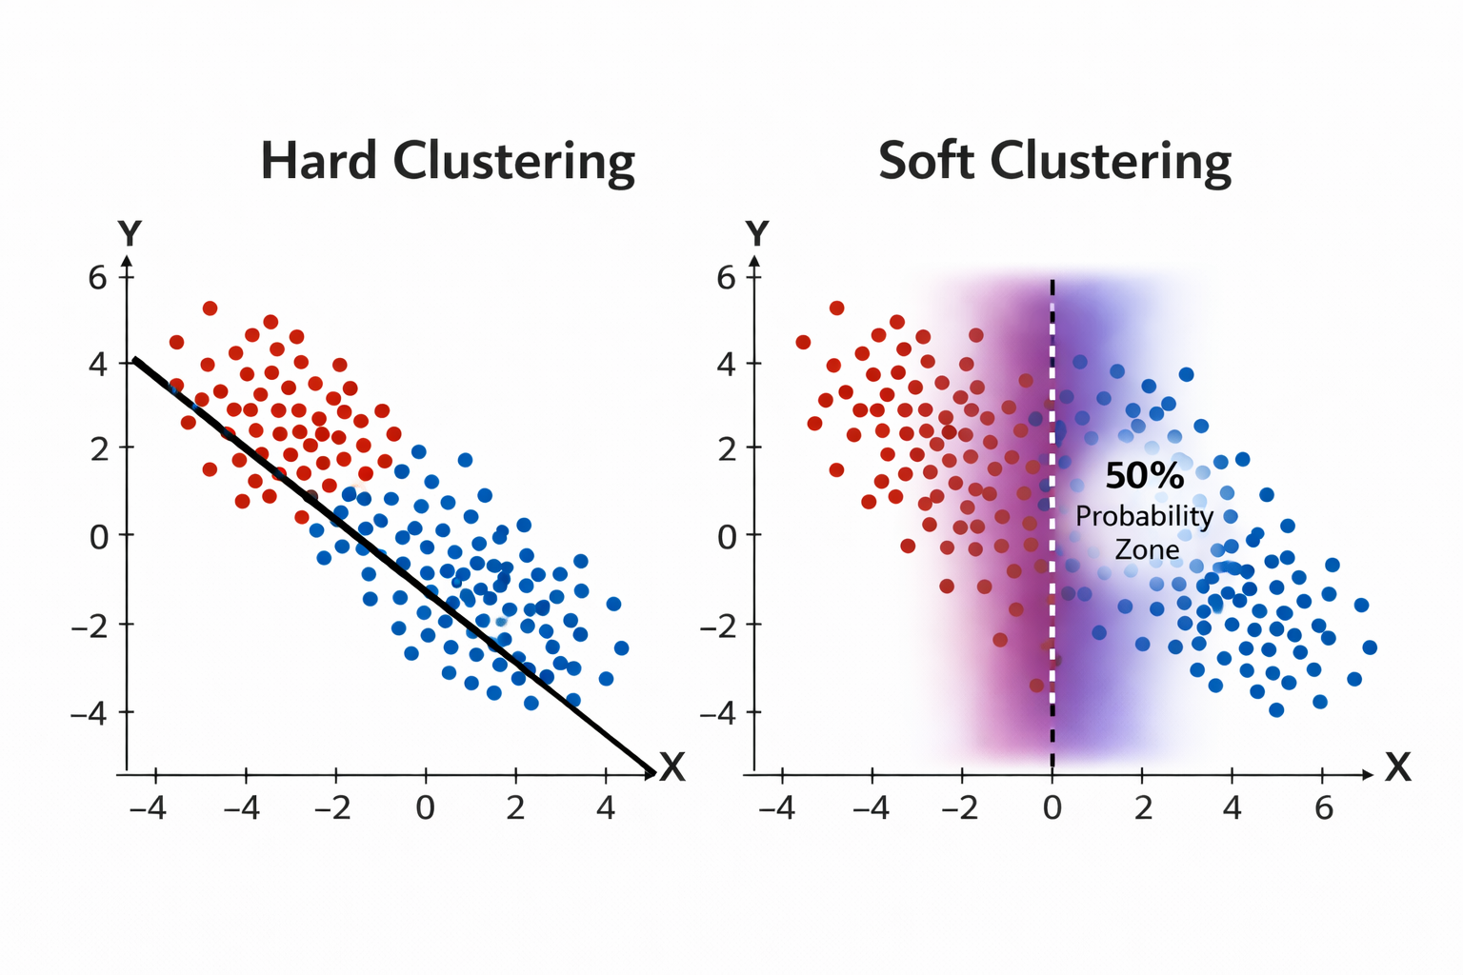
Real-World Ambiguity
Most real-world data requires soft clustering. A news article might be 80% about politics and 20% about economics. Soft clustering captures this overlap instead of discarding the secondary information.

Latent Variables
To calculate the probabilities used in soft clustering, we use latent variables. This changes how we define the dataset.
Observed vs. Unobserved Variables
- Observed Variables ( X ): This is the data you possess. Examples include the pixel values of an image, the temperature reading from a sensor, or the coordinates of a point on a graph.
- Unobserved Variables ( Z ): Also called latent variables. These are the hidden factors or categories that created the observed data.
Hidden Structure in Data
Consider a dataset of physical characteristics: height, weight, and shoe size. These are the observed variables. In clustering, latent variables do not necessarily correspond to real-world labels. They represent hidden group structures inferred by the model.
In probabilistic clustering, we state that the clusters are the latent variables. We assume that an invisible mathematical rule (the cluster) generates each data point we see.
The Generative Flow Map
In probabilistic clustering, we assume the data was created by a specific, hidden process. We model this process using a top-down flow.
- Start.
- Select Latent State: The mathematical model picks a hidden cluster k based on its Select Latent State: A cluster is selected based on a probability distribution over all clusters.
- Apply Cluster Parameters: Each cluster has its own parameters (such as mean and variance) that define its distribution.
- Generate Data Point: A data point is sampled from the selected cluster’s distribution, making points more likely to appear near its center but still allowing variation.
- Repeat: The process loops to generate all points in the dataset.
- End.
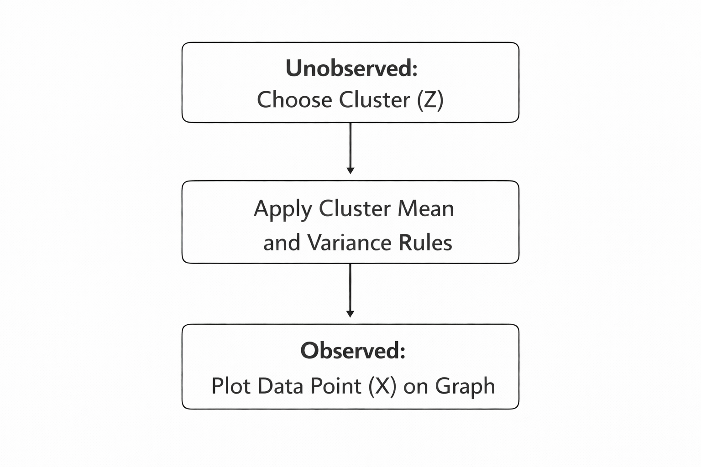
If clusters overlap and data is generated with uncertainty, assigning a single label is fundamentally incorrect. A better approach is to model data as being generated from multiple probability distributions, where each point has a degree of belonging to each cluster. This leads to probabilistic models such as Gaussian Mixture Models

QUIZ

- Which of the following is a key assumption of K-Means clustering that limits its effectiveness on elliptical clusters?
  - Equal density across all clusters
  - Assignment of outliers to a noise category
  - Spherical clusters based on Euclidean distance
  - Soft assignment of overlapping data points
- In the context of clustering, what does "Hard Clustering" refer to?
  - Assigning data points based on non-convex shapes
  - Assigning a data point to exactly one cluster
  - Using probability distributions for cluster membership
  - Identifying outliers as a separate latent state
- If a point has a 70% probability of belonging to Cluster 1 and 30% to Cluster 2, which method is being used?
  - K-Means Clustering
  - Hard Clustering
  - Soft Clustering
  - Deterministic Boundary Mapping
- In a dataset containing height and weight, what would biological sex be considered?
  - An observed variable (X)
  - A latent variable (Z)
  - A convex coordinate
  - An Euclidean distance metric
- Which step in the generative flow map involves the model retrieving center coordinates and variance rules?
  - Select Latent State
  - Generate Data Point
  - Euclidean Measurement
  - Apply Cluster Rules
Answer Key: 1. C, 2. B, 3. C, 4. B, 5. D

